NAME:_____________________________________ CLASS/PERIOD:___________ DATE:___________

BADMINTON CRYPTOGRAM PUZZLE

PHYSICAL EDUCATION EXTRA CREDIT ASSIGNMENT – 5 POINTS POSSIBLE
DIRECTIONS: Complete the Cryptogram puzzle below.
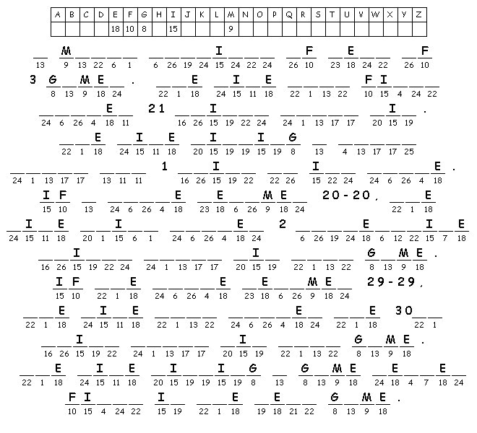
Hint: For Singles Matches, the RULES are:

